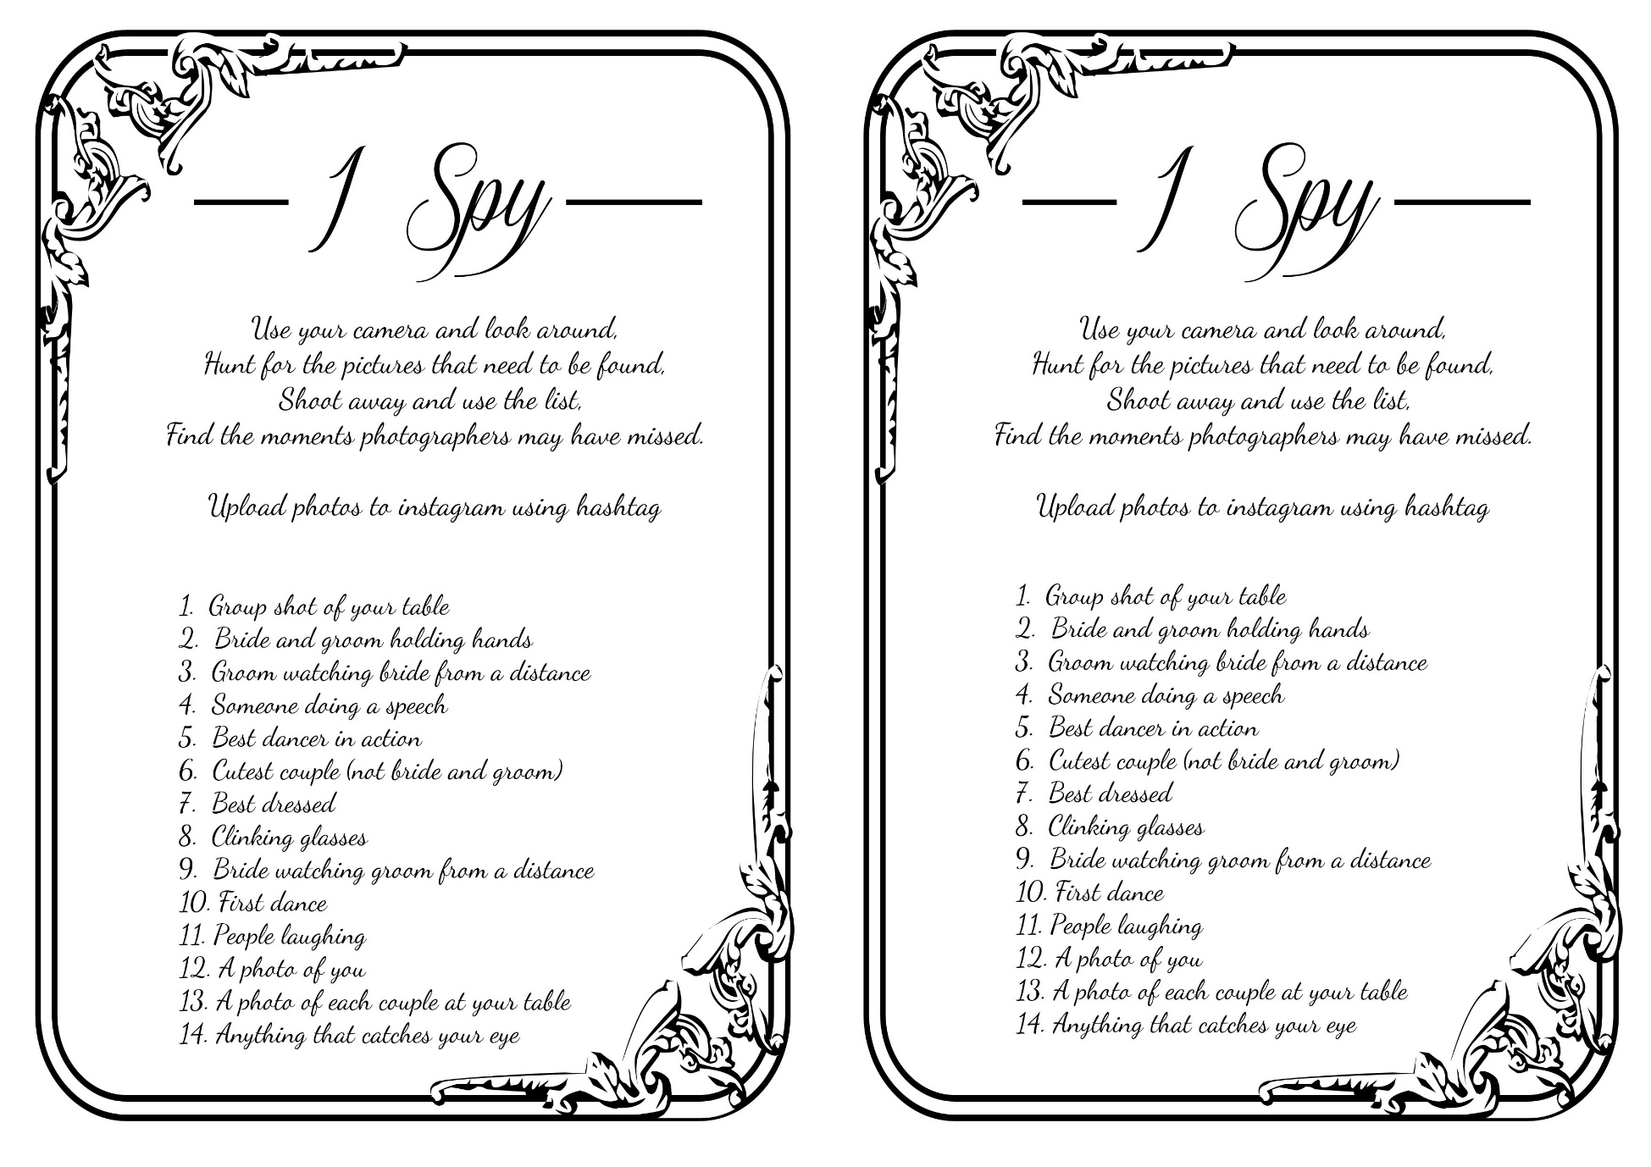

>>INSERT YOU HASHTAG HERE<<

>>INSERT YOU HASHTAG HERE<<